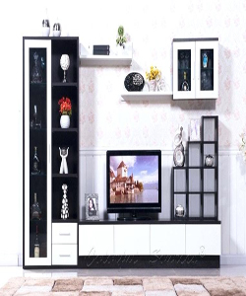

Simple Wood Divider

$140.49

Availability: In stock

**Description:**

Rosewood divider is cubic shape divider. Beautiful and 'The brilliant White and black color' for its vivid presentation. Available in different colors to make your home your ideal. this room divider can be used to define space in an open concept room, or can be set in front of a large window for privacy. Rounding out the design, metal hinges make folding and storage a breeze when not in use.